
PRACTICAL SKILLS TEST 2

TERM | COURSE NAME | COURSE CODE | VERSION
Winter 2021 | Cisco Networking Academy Training I | CIS701

Name | Caio Batinga
Student Number | 143575181
Pod # | Online

DATE: APRIL 6 2021

TIME ALLOWED: 105 MINUTES
PERCENTAGE: 10%
TOTAL MARKS: 10
PROFESSOR(S): Pedram Habibi

SPECIAL INSTRUCTIONS:

- Open book
- Use Packet Tracer and submit your simulation model online.
- Answer the questions in this document and insert screenshots where required. Submit the file online. Do not compress your files.
- Only perform tasks which are requested.
- If any value is not specified, choose your own but it must be correct.

This exam includes a cover page, plus two (2) pages of instructions and questions.

SENECA’S ACADEMIC HONESTY POLICY
As a Seneca student, you must conduct yourself in an honest and trustworthy manner in all aspects of your academic career. A dishonest attempt to obtain an academic advantage is considered an offense and will not be tolerated by the College.

Topology

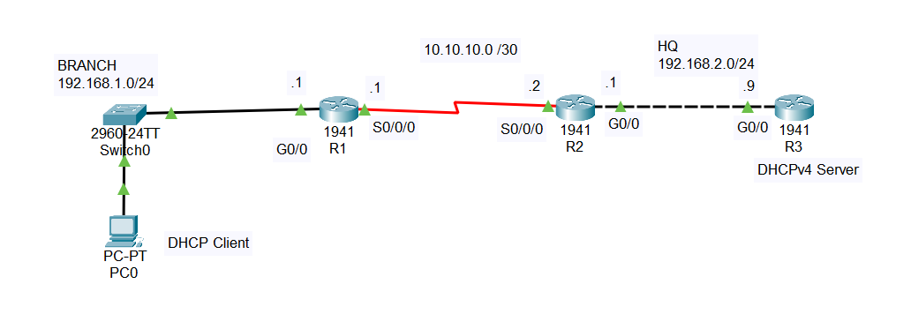
MARKING SCHEME

Part 1- Implement Topology [1 mark]
Part 2- Configure Devices [7 marks]
R1: [2 marks]
R2: [1.5 mark]
R3: [3 marks]
PC0: [0.5 marks]
Part 3- Verify Configuration [1 mark]
Part 4_ Reflection [1 mark]

PART 1- Build the network
Cable the network according to the topology provided. You do not need to include the labels.

PART 2- Configure the devices
Step 1: Configure all the router interfaces.
Step 2: Configure R3 as a DHCPv2 server, only for the HQ and BRANCH local area networks. On each LAN, reserve the first 9 IP addresses for static allocation. You only need to provide DHCP clients with a dynamic IP address and a default GW address (no need to set up DNS server, …).
You also need to configure this router for end-to-end connectivity to PC0.
Hint: Use a default static route.
Step 3: Set up R1 and R2 with appropriate routing configuration to enable end-to-end configuration between PC0 and the DHCP server.
Hint: You also need additional configuration on R1 to make DHCP work.
Step 4: Configure PC0 temporarily with a static IP address of 192.168.1.2/24 and default GW of 192.168.1.1.

PART 3- Verify Configurations
Step 1: Verify that PC0 can ping the server. No need for a screenshot.
Step 2: If the previous ping is successful, switch PC0 over to DHCP instead of static configuration. At this point, the PC must receive an appropriate IP address and a default GW address from the server.
Step 3: Issue an ipconfig command on PC0 and then immediately ping the server. It must be successful.
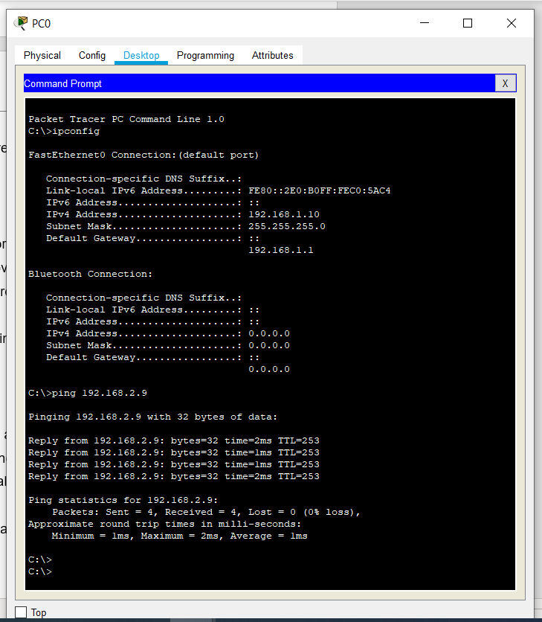

PART 4- Reflection
Question 1. Imagine R1 and R2 were connected using an Ethernet network instead of a serial link. What command would you use to make that Ethernet interface on R1 to receive an IP address automatically from the server instead of manually configuring it?
Ip address dhcp

Question 2. What other configuration would be necessary in that case on R2 and R3?
R2 Needs to be configured with the ip helper command and R3 needs the pool configured

